-- 3.Student Information Retrieval

--Develop a query to retrieve all students' information from the "student_table" and sort them in descending order by their grade.

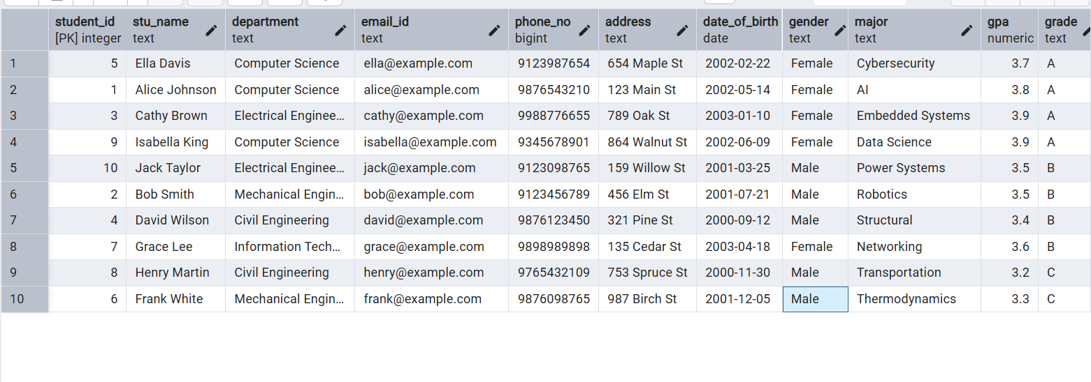

-- 4.Query for Male Students:

-- Implement a query to retrieve information about all male students from the "student_table."

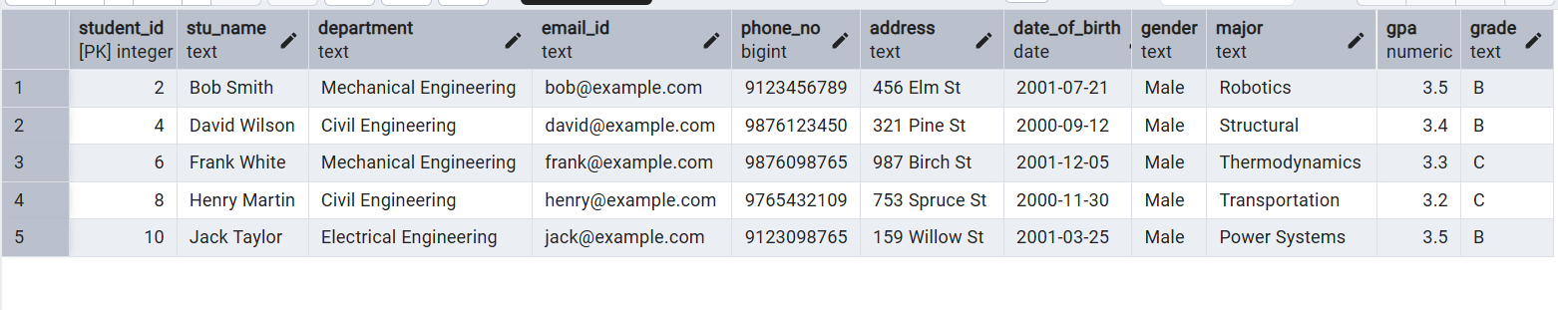

-- 5.Query for Students with GPA less than 5.0

-- Create a query to fetch the details of students who have a GPA less than 5.0 from the "student_table."

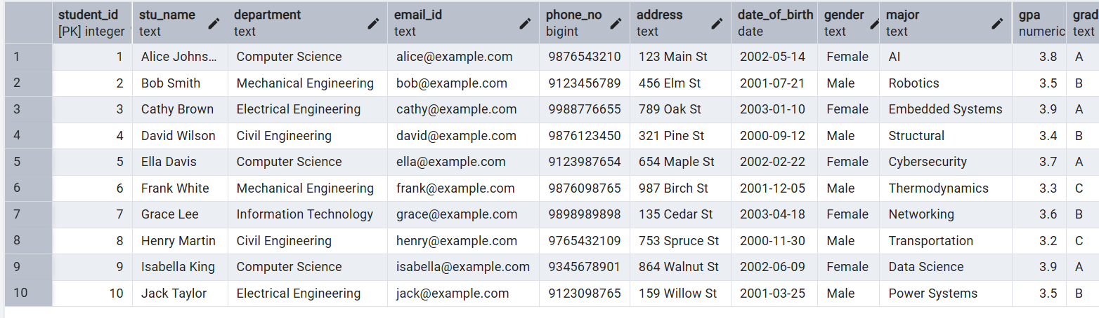

-- 6.Update Student Email and Grade

-- Write an update statement to modify the email and grade of a student with a specific ID in the "student_table."



-- 7. Query for Students with Grade "B"

-- Develop a query to retrieve the names and ages of all students who have a grade of "B" from the "student_table."

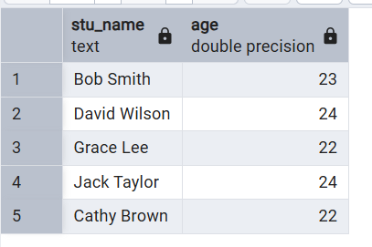

-- 8.Grouping and Calculation

-- Create a query to group the "student_table" by the "Department" and "Gender" columns and calculate the average GPA for each combination.

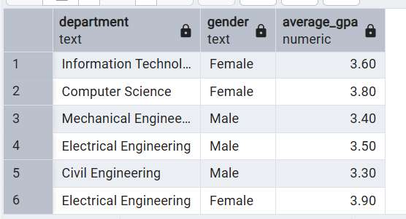

-- 9.Table Renaming

-- Rename the "student_table" to "student_info" using the appropriate SQL statement.

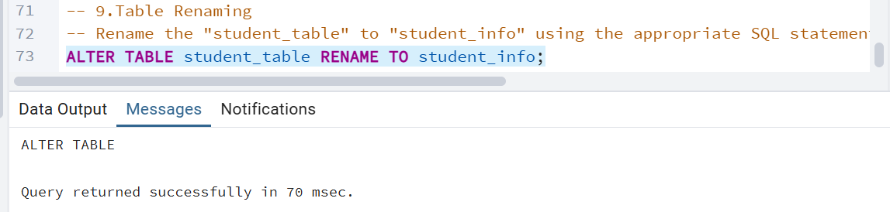

-- 10. Retrieve Student with Highest GPA

-- Write a query to retrieve the name of the student with the highest GPA from the "student_info" table.

